Internal Consolidated Participants Report
Mihir Kavishwar 2 Aug 2023

Summary
Teams
Participant 1: (M&S) Sumedha Raghu - Referred by Mihir Kavishwar
Summary
Technical
Non-Technical
Coordination
Participant 2: Sachin Singh - Referred by Mihir Kavishwar
Video link
Image
Summary
Technical
Front end
Back end
Readability & Standards
Functionality
Scalability
Architecture
Non-Technical
Coordination
Participant 3: (Enigma) Rishabh Nevatia - Referred by Mihir Kavishwar
Summary
Technical
Front end
Back end
Readability & Standards
Functionality
Scalability
Architecture
Non-Technical
Coordination
Participant 4: Charith Chandra Sai Balne - Referred by USC Career Center
Summary
Technical
Non-Technical
Coordination
Participant 5: Manasa Devarapalli - Referred by USC Career Center
Summary
Technical
Non-Technical
Coordination
Participant 6: Nanditha - Referred by USC Career Center
Summary
Technical
Non-Technical
Coordination
Participant 7: Kartik Pandey - Referred by USC Career Center
Summary
Technical
Non-Technical
Coordination
Participant 8: (The Ternary Operator) Mandar Mhapsekar - Referred by USC Career Center
Video link
Image
Summary
Technical
Front end
Back end
Readability & Standards
Functionality
Scalability
Architecture
Non-Technical
Coordination
Experiment feedback

Summary
In total, the experiment resulted in three submissions. Initially, the team's response was lackluster, possibly due to the company's lack of credibility or recognition. However, things changed when the career center department advertised the experiment on their Instagram page, gaining more attention. The team, particularly the well-qualified ternary operator, showed great enthusiasm throughout the competition and provided comprehensive explanations for most of the well-defined aspects.

Unfortunately, communication with the client was weak, and there were delays in following up, especially when founder issues arose. These issues were related to differing visions and the distribution of equity among the team members. As a result, the experiment's pace and competition performance suffered and became rather sluggish.

Despite these challenges, the team managed to secure three submissions out of eight registrations. However, only one of the submissions closely matched the client's requirements, and it even included some additional features.

The client, however, seemed uncertain and unimpressed with the options presented. They were running their beta and found that none of the team's designs aligned with their vision. Consequently, they are not interested in purchasing any solution, as they believe the invention is not up to the mark. Additionally, the client is considering a business pivot and does not appear to be enthusiastic about the project's continuation.

Teams

Participant 1: (M&S) Sumedha Raghu - Referred by Mihir Kavishwar

Summary
At the start, Sumedha displayed great enthusiasm and was the inaugural participant to enroll in the competition. Nevertheless, she struggled to match the pace of the project's advancement and eventually withdrew from participation halfway through. Although no code submissions or continuous project-related communication occurred, Sumedha did duly communicate her choice to depart.

Technical
Not applicable (N/A)

Non-Technical

Coordination
Coordinated well initially for onboarding.

Participant 2: Sachin Singh - Referred by Mihir Kavishwar

Video link
DandelionxEmpath - Sachin Singh.mp4

Image
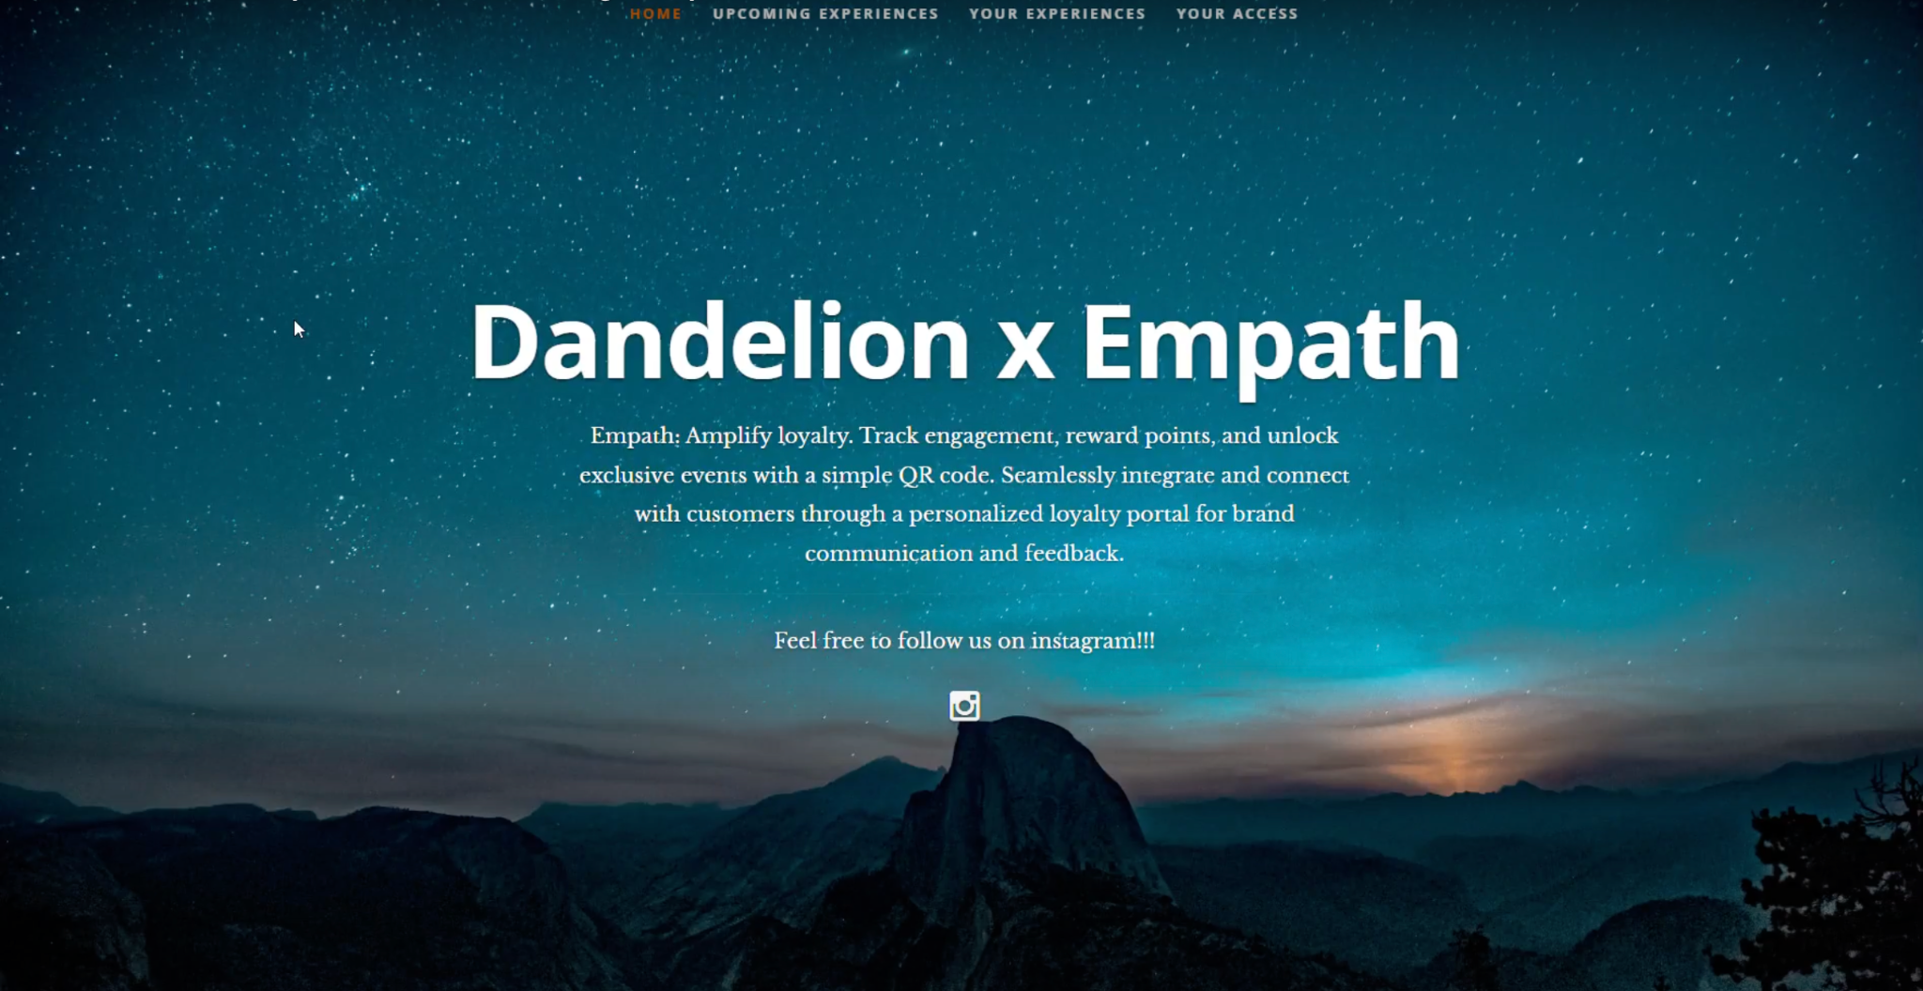

Summary
After becoming aware of the prize amount, participant count, and content prerequisites, Sachin submitted an application for the competition. Displaying keen interest, they engaged actively during the onboarding session and upheld effective communication through regular weekly calls. It's worth highlighting that Sachin stood out as the only participant who consistently delivered the mandated weekly progress reports.

Technical
The video mainly displays three key components of the code: aboutus.js, content.js, and header.js. These JavaScript files are responsible for organizing the arrangement of elements on the main page. In particular, the "aboutus.js" file handles testimonials, the "content.js" file manages the portfolio images, and the "header.js" file deals with showcasing experiences. The layout of the design is primarily controlled by the "layout.css" file, which has been specifically tailored for this design. It's worth noting that this CSS file is not easily adaptable to different client requirements.

Front end

Back end
Within the backend, you'll find the core file named "registerServiceWorkers.js." This file is responsible for housing callback functions that facilitate the data refreshing process from the database and the loading of services. It encompasses several functions, namely: registerValidSW, checkValidServiceWorker, register, and unregister. It's important to note that many backend functions are either absent or incomplete.

Readability & Standards
The code is quite readable and easy to understand. Variable names are of typical naming convention.

Functionality

Function | Assessment
A Landing page is linked from the client’s website to this website. | Not Present
User profile and login page and account management. | Not Present - User management is not present
Picking up purchase history from Client’s account. | Not Present
Picking up instagram likes on clients posts from the user. | No facebook api linked
Be responsive and work on all devices. | Using React which is responsive by itself
Be built in a way that would be easier integrations with more clients (Third party websites) | Hard files for css hard coded, not scalable.

Scalability
The project remains unfinished and lacks scalability. The design has been hardcoded and lacks any form of user management system.

Architecture
Api used:
- React
- ReactDOM
- registerServiceWorker

import React from 'react';
import ReactDOM from 'react-dom';
import './index.css';
import App from './App';
import registerServiceWorker from './registerServiceWorker';


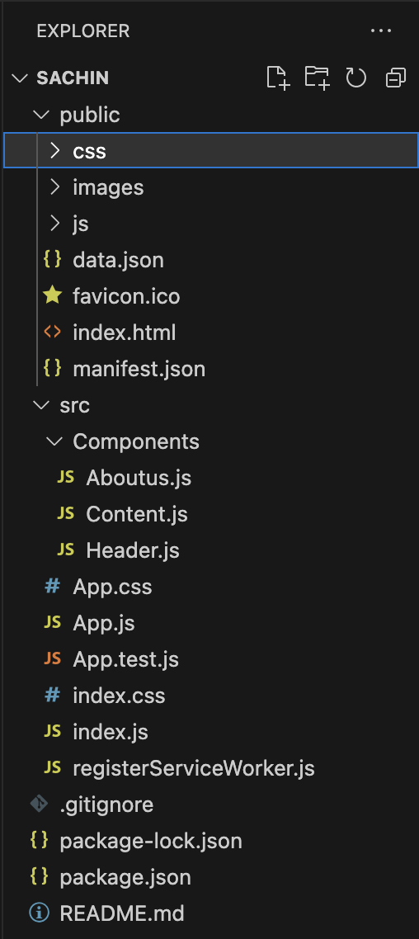

Non-Technical

Coordination
In the beginning, the coordination was robust; however, it gradually weakened over time, and insufficient work efforts were evident towards the project's conclusion.

Participant 3: (Enigma) Rishabh Nevatia - Referred by Mihir Kavishwar

Summary
Most of the project submitted by Rishabh is incomplete. It consist of the front end and client-server model but no user management architecture or the instagram integration.
Rishabh participated in an onboarding call with Devin Ardalan and set up a regular weekly meeting. Nevertheless, during one instance, Rishabh joined the meeting without proper preparation and lacked any content to present or discuss. Furthermore, Rishabh handed in the code two days after the competition's final deadline.

Technical

Front end
The front end is not appealing and basic.
Main components in the front of the client is as follows.
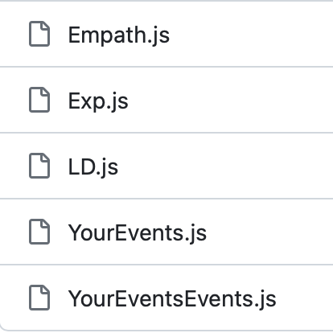
Empath contains the layout of the main page containing: "UPCOMING EXPERIENCES," "YOUR EXPERIENCES," and "YOUR ACCESS."
The layout of the experiences are given in Exp.js
LD is the link to the landing page.

Back end
The web performance, monitored through the utilization of the web vitals library, was an additional feature that wasn't obligatory but was included nonetheless. However, a significant portion of the required functionality and the backend architecture remains incomplete, such as aspects like user management and the creation of adaptable, scalable functions. It's worth noting that no interactions with Facebook APIs were made.

Readability & Standards
The code's readability is lacking, and the variable names do not adhere to the prescribed naming convention.

Functionality

Function | Assessment
A Landing page is linked from the client’s website to this website. | Linked using file LD.js
User profile and login page and account management. | Not Present - User management is not present
Picking up purchase history from Client’s account. | Not Present
Picking up instagram likes on clients posts from the user. | No facebook api linked
Be responsive and work on all devices. | Using React which is responsive by itself
Be built in a way that would be easier integrations with more clients (Third party websites) | No infrastructure for scaling or flexibility.

Scalability
The code lacks scalability as the infrastructure isn't connected to the database, causing operations to occur within the cache.

Architecture
Architecture consist of the client-server.
Libraries used:
- React
- ReactDOM
- reportWebVitals
import React from 'react';
import ReactDOM from 'react-dom/client';
import './index.css';
import App from './App';
import reportWebVitals from './reportWebVitals';


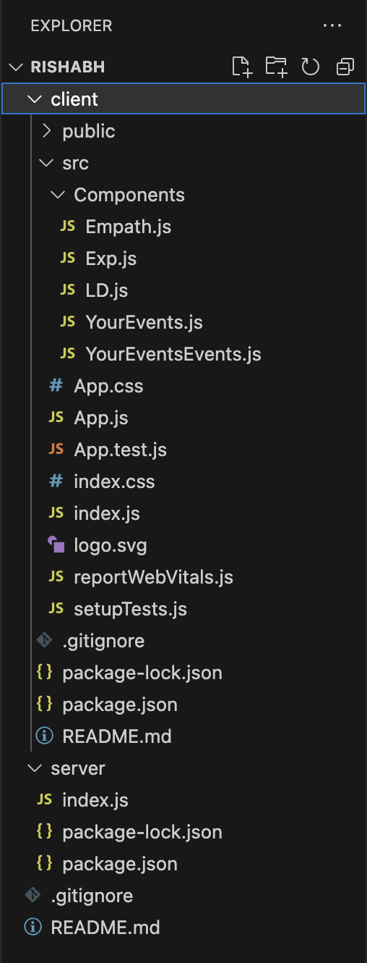

Non-Technical

Coordination
Rishabh initially displayed good coordination, but failed to provide weekly reports as agreed upon. Rishabh's collaboration with Devin Ardalan was evident only during the first report, where he communicated that he hadn't commenced the work yet.

Participant 4: Charith Chandra Sai Balne - Referred by USC Career Center

Summary
Charith joined the WhatsApp group quite late and did not maintain regular follow-ups. Unfortunately, no code was submitted by Charith, and there were no responses or contributions from them within the group.

Technical
Not applicable (N/A)

Non-Technical

Coordination
Lack of effective coordination, absence of code submissions or regular weekly meetings, and minimal engagement within the group.

Participant 5: Manasa Devarapalli - Referred by USC Career Center

Summary
After coming across the competition advertisement from the career center, Manasa decided to join. During the onboarding call, Manasa appeared composed and engaged. However, after that initial interaction, there was no further communication or interaction from Manasa. In the beginning, Manasa expressed concerns about performance and system-level testing, which were also addressed during the onboarding call. Unfortunately, Manasa did not submit any code for the competition and did not schedule any weekly follow-up calls.

Technical
Not applicable (N/A)

Non-Technical

Coordination

Participant 6: Nanditha - Referred by USC Career Center

Summary
Nanditha joined the competition after learning about it from the career center advertisement. Despite being new to full-stack development, Nanditha did not submit any code for the competition.

Technical
Not applicable (N/A)

Non-Technical

Coordination
Nandita initially collaborated with Devin Ardalan at the start of the competition, but subsequently, she did not continue her involvement in the project. She briefly engaged in the group chat during her participation.

Participant 7: Kartik Pandey - Referred by USC Career Center

Summary
Kartik applied to the competition after seeing the advertisement on the career center. However, Kartik later decided to notify the organizers and withdrew from the competition.

Technical
Not applicable (N/A)

Non-Technical

Coordination

Participant 8: (The Ternary Operator) Mandar Mhapsekar - Referred by USC Career Center

Video link
Empath - Mandar Mhapsekar.mp4
Experience by Empath - Team Ternary Operator

Image
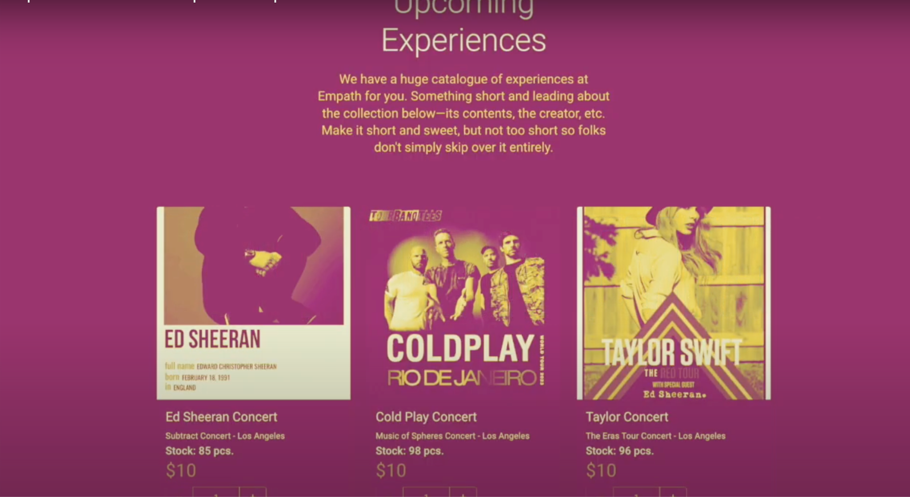

Summary
The majority of the required functions are included as specified in the project requirements. The project has been well-developed with a stable architecture, and although the frontend design is not an exact match to the Canva design, it remains visually appealing. The Ternary Operator team distinguished themselves as the top team among all the competing teams. They entered the competition after coming across the advertisement, and each of their members registered using the provided link. During the report call, they presented their information meticulously, showcasing a strong alignment with the given guidelines. They actively engaged by posing pertinent questions and demonstrating effective interactions. The team's performance went beyond expectations, as they not only met but exceeded them by incorporating an additional admin portal feature. This exceptional achievement set them apart from the other participants.

Technical

Front end

Back end

Readability & Standards
The readability and adherence to naming standards are excellent. The code is straightforward and easy to comprehend.

Functionality

Function | Assessment
A Landing page is linked from the client’s website to this website. | Present
User profile and login page and account management. | Present
Picking up purchase history from Client’s account. | Present, handled by model (dto)
Picking up instagram likes on clients posts from the user. | Present
Be responsive and work on all devices. | Yes, using React.
Be built in a way that would be easier integrations with more clients (Third party websites) | Not present, new stylesheets have to be designed for new clients (only night mode available)

Scalability

Architecture
The architecture is robust, employing MySQL for effective database management, and the Java Spring Boot API for the backend functionalities. The implementation incorporates the MVC (Model-View-Controller) design pattern, with both the model and controller components coded in Java. This design extends to encompass internal operations and external agents, such as Instagram.

Controllers constitute:
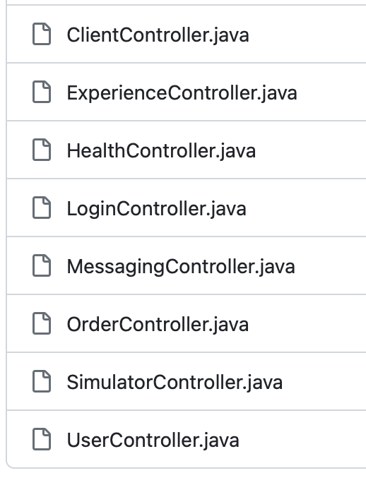

Internal model represents:
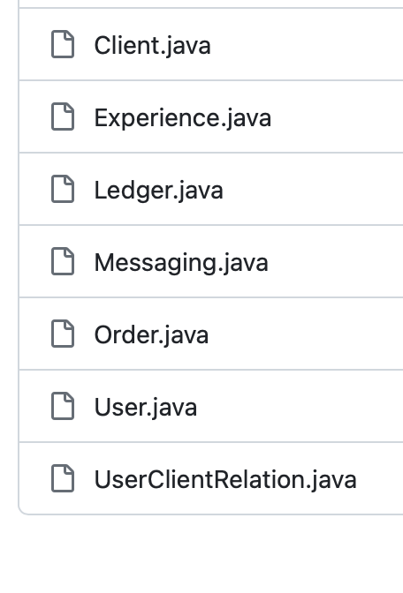
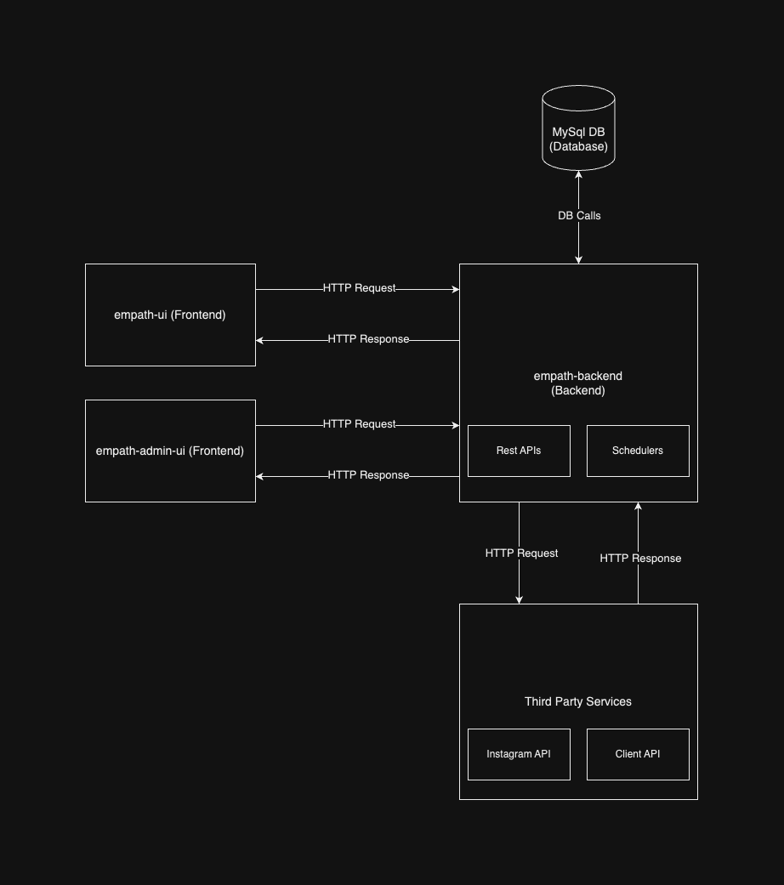
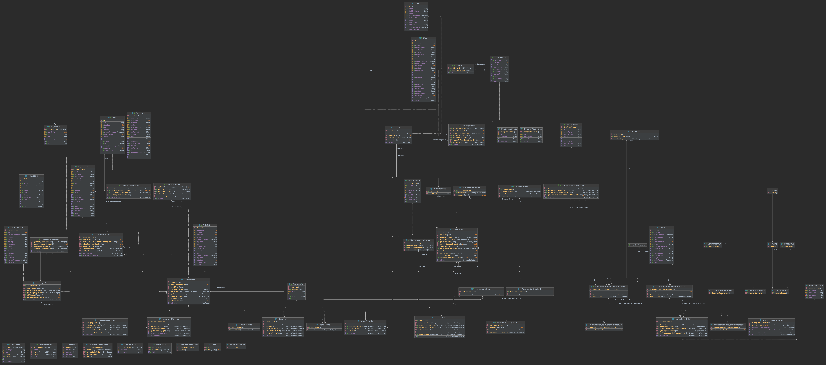

Non-Technical

Coordination
The coordination was consistently excellent. All the details were thoroughly explained, and queries were posed for clarifications. Collaboration was smooth, and responses to questions during the code review were prompt. A comprehensive readme file was generated, facilitating a clear understanding of the code architecture and making it easier to interpret.

Experiment feedback

